DEMOGRAPHICS

Cabell Midland High School is a four year high school which serves grades 9 through 12. The school was established in the fall of 1994 as a result of the consolidation of Milton High School and Barboursville High School. Our goal at Cabell Midland High School is to provide an educational journey that will enable all students to achieve the best of their unique potentials in becoming contributing citizens of the world.

The school is located on a rural campus and our students are primarily middle‐class rural, suburban, or small-town environments. The majority of the student population resides in the eastern part of Cabell County including Milton Middle School and Barboursville Middle School.

Cabell Midland High School currently has 120 teachers, 6 adjunct teachers, 6 counselors, an Academy Coordinator, a Graduation Coach, a Systems Operator, and 6 administrators. We have a devoted and professional staff that is committed to providing a supportive learning environment for all students. We are focused and dedicated to the success of every student in our school.

The school currently enrolls 1,937 students. Currently 68% of graduates attend a four‐year college or university or a two year technical school.

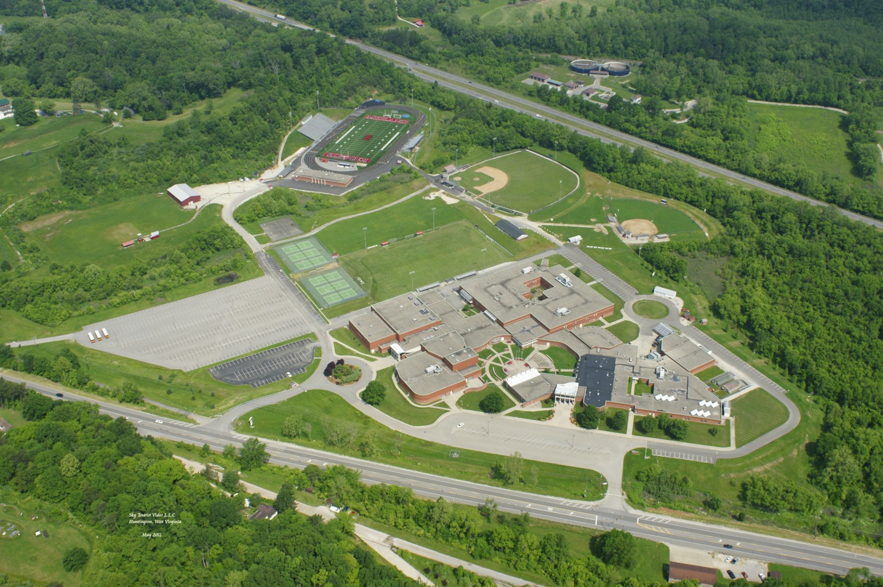

GRADUATION REQUIREMENTS & CURRICULUM

Cabell Midland High School currently has a graduation rate of 89.15% (2016-17). With the class of 2006 and beyond, students shall achieve 24 high school graduation credits to be eligible to receive a high school diploma.

English Language Arts | 4 credits
Mathematics | 4 credits
Science | 3 credits
Social Studies | 4 credits
Physical Education | 1 credit
Health | 1 credit
The Arts | 1 credit
World Languages | Undergraduate admission to West Virginia four-year colleges and universities include the completion of two units of the same world language.
Electives | 4-6 Credits

Cabell Midland High School graduates are required to complete at least 10 hours of community service.
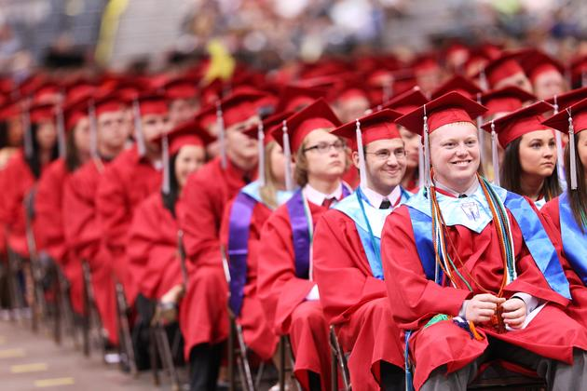
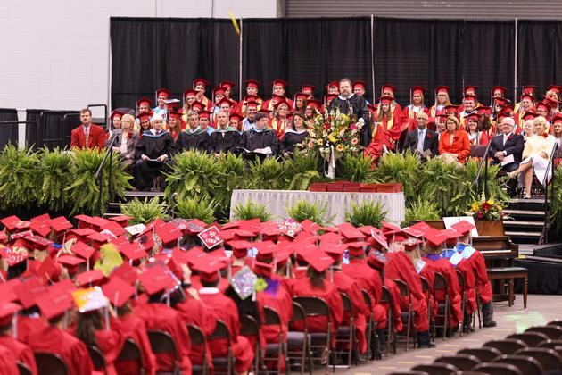

COURSE OFFERINGS

Cabell Midland High School offers a rigorous curriculum with Advanced Placement, Dual Credit, and Honors level in all core subjects including the fine arts and CTE (Career and Technical Education). Students may substitute these courses for general courses.

Advanced Placement | Marshall University and MCTC Dual Credit | Honors Courses
AP Calculus AB | Math 121 | Geometry and Algebra II Honors
AP Calculus BC | Math 127 | World History Honors
AP English Language | Communications 103 | Trigonometry Honors
AP English Literature | English 101/102 | Pre-Calculus Honors
AP Biology | Math 122 | Earth and Space Science Honors
AP Chemistry | ROTC 2 and 4 | Biology Honors
AP Physics B | Medical Terminology AH 151 | Human Anatomy Honors
AP Statistics | Careers in Health Science AH 100 (Foundations of Health) | Physics Honors
AP U.S. Government and Politics | BSC 104/105 | Spanish Honors
AP U.S. History | History 103 (20/21st Century) | Chemistry Honors
AP World History | Vet Science 101 (Small Animal Care) | Latin Honors
AP Psychology | ECE 101 (Early Child Education) | Japanese Honors
AP Environmental Science | ASL | Debate Honors
AP Studio Art | Marketing 101 | Collegium Music Honors
AP Music Theory | Math 225 | Show Choir Honors
AP Human Geography | ROTC 2 and 4  MILS 101, MILS 201, MILS 201 Lab | Wind Ensemble Honors
AP Euro History |  | Music Theory Honors
AP Computer Science |  | CDS III & IV Honors
 | Business Computer Applications IT 101 | English 9 & 10 Honors

CLASS RANK & GRADING SCALE

Cabell Midland High School students’ cumulative grade point average (GPA) is based on all
courses completed during the entire four years of high school. Class rank and cumulative GPA’s
are weighed on a 4.0 + scale. Each honor and or AP course is awarded one extra quality point.

90‐100 | A | 4.0
80‐89 | B | 3.0
70‐79 | C | 2.0
60‐69 | D | 1.0
0‐59 | F | 0.0

TESTING

The Class of 2017 consisted of 438 graduates. They performed as follows on the ACT and SAT I:

- ACT: 270 tested. The mean composite score was 21.8 (average state score is 20.4 and National Average is 21).
- In 2017 the average score for Cabell Midland in English was 21 (20 for state average), math was 20.6 (19.4 state average), reading was 22.8 (21.2 state average), science was 22.2 (20.5 state average).
- SAT I: 31 tested in 2017. The mean score for Cabell Midland was 1183 (district average was 1168 and state average was 1083).

SCHEDULE

The school uses a seven module schedule. Some classes are taught as a “double mod” (1.0 credit per semester) and some are taught as a “single mod” (0.5 credits per semester).

CABELL MIDLAND KINGHTS ATHLETICS

Cabell Midland High School offers a wide variety of athletics for both male and female students. Cabell Midland is a top contender across the state in all sports.

Fall Sports
Winter Sports
Spring Sports

Football Girls Basketball Tennis
Cheerleading Boys Basketball Baseball
Boys Soccer Wresting Softball
Girls Soccer Swimming Track and Field
Cross Country (Boys and Girls)
Archery
Volleyball
Golf
Marching Band

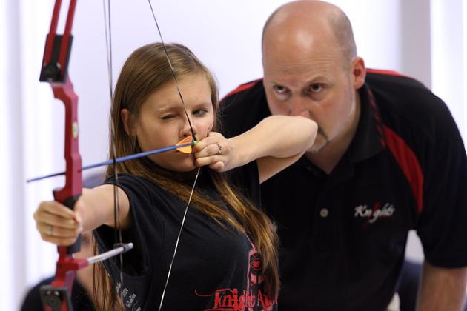

EXTRA-CURRICULAR ACTIVITIES: PROGRAMS & CLUBS

Academic Honoraries
Art Honorary
Chemistry Honorary
French Honorary
Honors Biology Club
Honors Program
La Sociedad Honoraria Haspanica
Latin Honorary
Mu Alpha Theta
National Honor Society
Physics Honorary
Distinguished Scholars Program
Tri- M Music Honorary
BETA Club

Career Focused Organizations
Distributive Education Clubs of America - DECA
Future Business Leaders of America - FBLA
Future Educator's Association - FEA
Future Farmers of America - FFA
Health Occupations Students of America - HOSA
Health Science Technology Academy – HSTA

Service Organizations
Go MAD Midland
Key Club
LEO Club
Operation Smile
Peer Assisted Games
Students Against Drunk Driving - SADD

Student Leadership
AFJROTC-Raiders
Principal Advisory
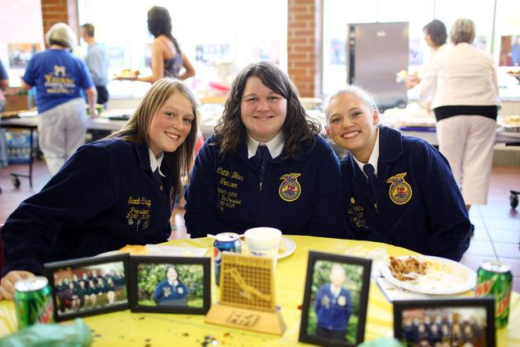
Student Council
Teenage Republicans/Young Democrats

Clubs & Student Interest Groups
American Sign Language
Archery Club
Board Games
Chess Club
Cycling Club
ECO Awareness Club
Fantasy Basketball/History of Basketball Club
Fashion Awareness Club
Fellowship of Christian Athletes - FCA
Fitness Club
Gaming Club
Gay, Straight Alliance - GSA
Glee Club
Hobby Club
Japanese Club
Jazz Club
Kitty Hawk Air Society - KHAS
Martial Arts Club
Mass Media Club
Military History
Outdoor Club
Pep Club
Photography Club
Rugby
Science Club
Sci-Fi Club
Social Psychological Club
Support Our Troops
Ultimate Frisbee Club
Upward Bound
Yearbook
Newspaper

